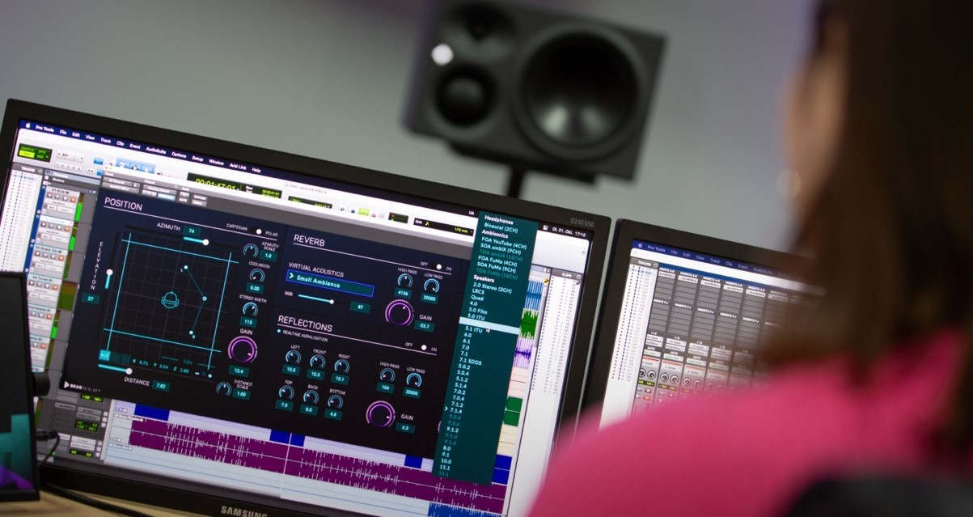
Dear Reality releases dearVR PRO 2 spatializer plugin
Successor software adds exciting capabilities for immersive audio – and a brand-new stereo feature

Sydney Australia, January 17, 2024 – Today, spatial audio expert Dear Reality has launched dearVR PRO 2, the successor of its popular dearVR PRO spatializer. The upgrade adds a stereo input including stereo width control to the plugin, and gives users access to new immersive Pro Tools formats (9.0.4, 9.1.4 and 9.0.6). dearVR PRO 2 also features new high-pass and low-pass filters for early reflections and late reverb, designed to bring trueto-life sound to any production. In addition, the new Mk II software supports third-party OSC head trackers.

The demand for spatial audio productions that captivate and fully immerse audiences has never been higher, and with it comes a need for spatial audio software solutions, as they enable engineers and musicians to test the immersive audio waters very efficiently without breaking the bank. dearVR PRO 2 is at the forefront of this audio revolution, providing users with a sophisticated yet easy-to-use toolset to craft spatially rich and emotional soundscapes.

“Simulating distance in spatial audio productions is essential when creating truly authentic 3D spaces. Just one spherical plane with a fixed distance around the listener will not do the trick,” says Dear Reality co-founder Christian Sander. “dearVR PRO 2’s distance simulation unlocks a fully natural depth perception for multi-channel formats and lets the user place the sound seamlessly – even behind the loudspeakers.”

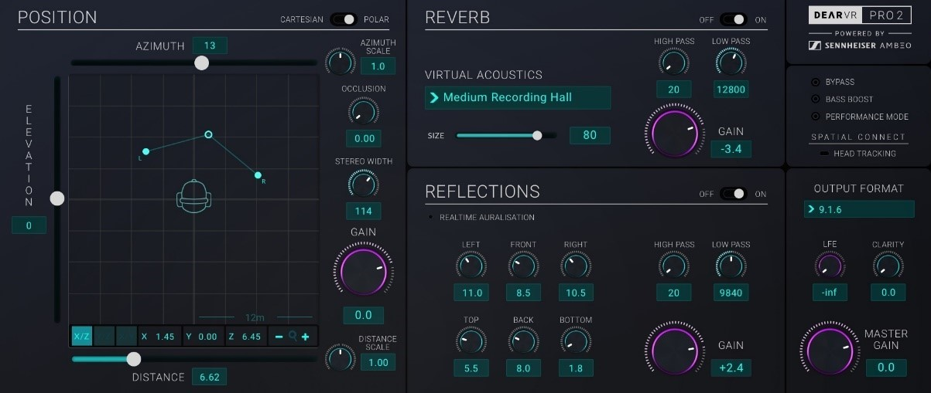
The dearVR PRO 2 graphical interface with XYZ position, early reflections, late reverb, and output sections

With true-to-life early reflections and 46 virtual acoustic presets – from a small car to a large church – dearVR PRO 2 is ideally suited for professional music and postproduction, enhancing them with an accurate perception of direction, distance, reflections, and reverb. The newly added filter modules, each consisting of a high- and low-cut filter, expand the versatility and reduce unwanted rumbling or harsh frequencies in the early reflections or late reverb section.

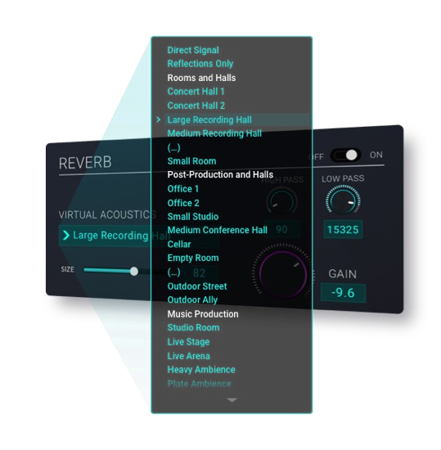
dearVR PRO 2 offers 46 virtual room acoustics for postproduction and modern music production

The dearVR PRO 2 output section features 35 multi-channel loudspeaker formats, including the latest 9.0.4, 9.1.4, and 9.0.6 Pro Tools® DAW formats. Furthermore, the all-in-one spatializer offers Ambisonics – up to third order – and binaural outputs, making dearVR PRO 2 the perfect tool for advanced XR productions.

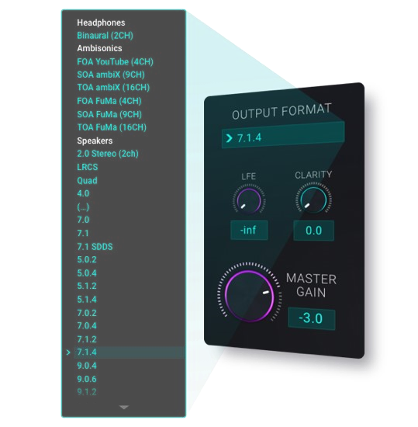
dearVR PRO 2’s output section with a selection of its binaural, Ambisonics and multi-channel speaker formats

dearVR PRO 2 follows Dear Reality’s easy-to-use approach, enabling the user to focus on what matters most – the audio – by reducing unnecessary menus or disruptive overlays. The plugin provides direct access to the audio position using a graphical XYZ pad in 360°. Placing audio behind or in front the listener, above or below, to the left or right, closer or farther away was never easier.

The software’s new stereo input feature expands this concept to stereo tracks, enabling direct access to the stereo width and making the plugin the perfect spatializer for stem productions. "Recording audio with stereo miking techniques is still common practice, even for the creation of advanced three-dimensional experiences," says Felix Lau, Product Owner at Dear Reality. “dearVR PRO 2 helps the engineer to effortlessly position stereo recordings of instruments and ambiance in a spatial sound field.“

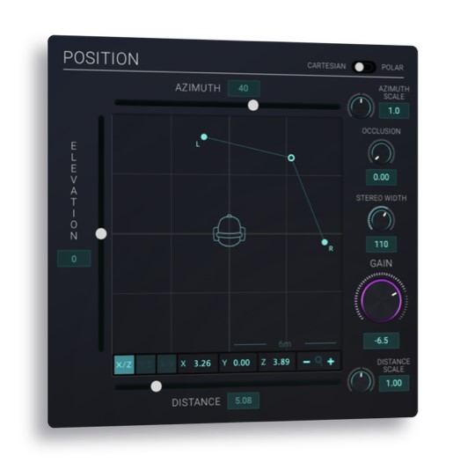
dearVR PRO 2’s re-worked XYZ position module, including the new stereo input feature

In addition to the existing connection to the dearVR SPATIAL CONNECT VR controller, dearVR
PRO 2 can now also be connected to any third-party OSC head tracker using the included SPATIAL CONNECT ADAPTER. Users will benefit from an extended head-tracking control and a much more natural way to judge immersive productions.

Pro Tools® is a trademark of Avid Technology Inc., registered in the U. S. and other countries.

The images accompanying this media release can be downloaded here.
For more information, please visit: https://www.dear-reality.com/products/dearvr-pro-2

dearVR PRO 2 is available for 199 USD (excl. VAT) at dear-reality.com and selected dealers.
During the introductory period until January 31, dearVR PRO 2 is available for 149 USD (excl.
VAT).

Existing dearVR PRO users can upgrade to the Mk II version for 79 USD here
(https://www.dear-reality.com/pages/pro-2-upgrade).

About Dear Reality
Dear Reality is a leading company in the field of immersive audio controllers and is best known for its binaural, Ambisonics, and multichannel spatializers with totally realistic room virtualisation. Sound engineers, sound designers, broadcasters, and musicians use the company's products worldwide. Founded in 2014 by Achim Fell and Christian Sander, Dear Reality strives to deliver high-quality, cutting-edge 3D audio software for interactive and linear audio production. Since 2019, Dear Reality has been proud to be a part of the Sennheiser Group.

Global Press Contact

Kai Detlefsen press@dear-reality.com

Sennheiser Communications Manager – Americas & ANZ, Sennheiser Electronic Corporation
Daniella Kohan
Daniella.kohan@sennheiser.com
+1 860-598-7514

